Friends of RI CASA
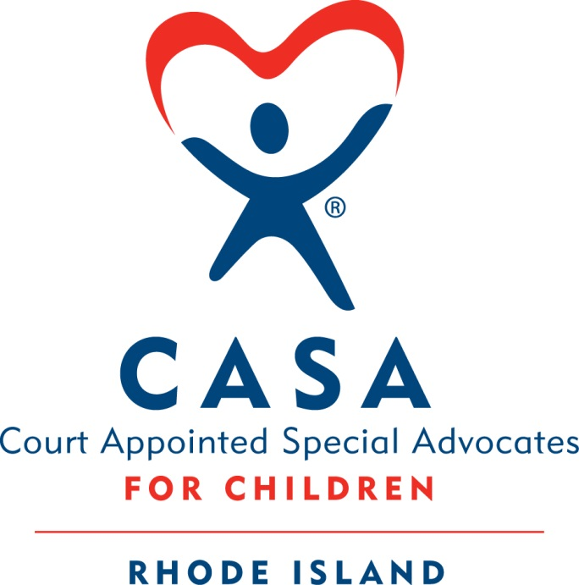
End of Summer Celebration!
Sunday, September 8, 2019
Bonnet Shores Beach Club
All proceeds will benefit abused and neglected children served by the RI CASA program.

Sponsor Levels

Lifesaver: Company recognition on: -all publicity, $5,000 ______
event banner, tables, website, social media.
Eight event tickets.

Guardian: Company recognition on: event banner, $2,500 ______
tables, website, social media posts.
Six event tickets.

Advocate: Company recognition on: tables, $1,000 ______
website, social media posts.
Four event tickets.

Friend: Company recognition on tables. $ 500 ______
Two event tickets.

Individual tickets: Adult Enjoy music and great food at a beautiful location! $40 ea. ______
Child …………………………………………………………………………………………. $20 ea. ______

$ Donation: Any support is welcome and will be acknowledged. $ ____________

Donation of Raffle Item: ______________________________________ All items welcome!

Company: Contact:

Friends of RI CASA’s
Tax ID # is
05-0461271

Address: City/State/Zip:

Phone: ( ) Email:

Special Requests:
Questions: email friendsofricasa1978@gmail.com

PLEASE SEND THIS FORM AND CHECK TO:
Friends of RI CASA, Inc.
P.O. Box 20059
Cranston, RI 02920

