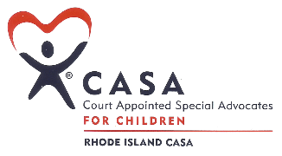

FRIENDS OF RHODE ISLAND CASA, Inc.

PO Box 20059

Cranston, Rhode Island 02920

**ADVERTISEMENT FORM**

To purchase an ad in our program, please fill out the form below. The program will be distributed to all attendees at the *End of Summer Friends of RI CASA Fundraiser*, held at Bonnet Shores Beach Club on **Sunday, September 8, 2024.**

Choose Option Below:

1. Inside Cover - **SOLD** $300.00
2. Inside Back Cover - **SOLD**  $300.00
3. Back Cover Only - **SOLD**  $300.00
4. Full Page $150.00
5. Half Page $100.00
6. Business Card $50.00

Please include a business card or artwork and a personal message that you would like to go along with your advertisement. Checks should be made payable to Friends of Rhode Island CASA. Please mail this form and advertisement, along with your payment, to Friends of RI CASA, P.O. Box 20059, Cranston, RI 02920.

*If you would like to receive a complimentary copy of the program, please complete the information below:*

Name: _____________________________________________________________________­­__________

Company: ____________________________________________________________________________

Address: _____________________________________________________________________________

Please contact Kristina Poli at 401-996-0184 if you have any questions.

Thank you for placing an ad in the *End of Summer Friends of RI CASA Fundraiser*!

Kristina Poli

Secretary

Friends of RI CASA