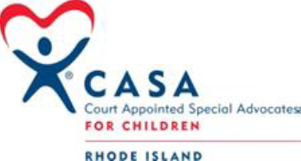

*FRIENDS OF RI CASA*

*END OF SUMMER CELEBRATION FUNDRAISER*

Sunday, September 8, 2024

Bonnet Shores Beach Club

175 Bonnet Point Road, Narragansett, R.I. 02882

SPONSOR LEVELS

Dreams Come True Sponsor $200.00

(5 Sponsor Slots)

Covers expenses/purchases up to $200 for certain urgent basic needs and activities/items that support the social, educational, emotional development and independent needs of children and older youth represented by the RI CASA Program.

Dessert Sponsor $400.00 (3 Sponsor Slots)

Name Recognition - fundraiser ad booklet & dessert tables

Bonnet Celebration Sponsor $1,000.00

(4 Sponsor Slots)

Name Recognition – live & social media, fundraiser ad booklet & tables

Entertainment Sponsor $1,000.00

(1 Sponsor Slot)

Name Recognition - fundraiser ad & will be announced by the live entertainment

Food Sponsor $1,500.00 (2 Sponsor Slots)

Name Recognition - fundraiser ad booklet & buffet tables